

Programming Fundamentals

Assignment No 11

Student Name :MOMIN HAYAT KHAN

Roll No: S20-0273

Department :BS(Artificial Intelligence)

Batch / Year:SPRING 2020

Lecturer: Mam Misbah

Program No 1:

Write a program that create a text file ―example.txt‖. Open that file and write two line in it ―This is a line and This is another line‖ and close the file. If the file is unable to create or open then show a message ―ERROR Unable to open a file‖.

|  |
| --- |
| #include <stdio.h>  #include <string.h>  int main()  {     FILE *filepointer;     char line1[]={"This is a line."};     char line2[]={"This is the second line."};     filepointer=fopen("example.txt","w");     if (filepointer== NULL)     {        printf("ERROR Unable to open a file");     }     else     {        if (strlen(line1)>0)        {           fputs(line1,filepointer);           fputs("\n",filepointer) ;           fputs(line2,filepointer);        }       }       fclose(filepointer);  } |

Output:

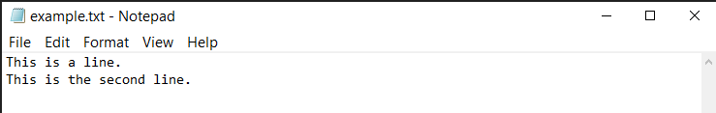

Program No 2:

Write a program that read the text from file ―example.txt‖.

If the file is unable to open then show a message ―ERROR Unable to open a file‖.

|  |
| --- |
| #include <stdio.h>  #include <string.h>  int main()  {     FILE *filepointer;     int ch;     filepointer = fopen("example.txt","r");     if (filepointer==NULL)     {        printf("File failed to open");     }     else     {        int ch = getc(filepointer);        while (ch!=EOF)        {           putchar(ch);           ch = getc(filepointer);        }       }       fclose(filepointer);     printf("\nThe file is now closed");  } |

Output:

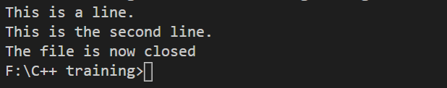

Program No 3:

Write a program that create a text file ―fdata.txt‖. Open that file and write the values through variables as under. After successful writing show a message ―File written successfully‖ .

char ch = 'x'; int j = 77;

double d = 6.02;

string str1 = "How are u? "; string str2 = "Pretty Good";

|  |
| --- |
| #include <stdio.h>  #include <string.h>  #include <iostream>  using namespace std;  int main()  {     char ch = 'x';     int j = 77;     double d = 6.02;     char str1[] = {"How are u?"};     char str2[] = {"Pretty Good"};     FILE *filepointer;     filepointer = fopen("fdata.txt","w");     if (filepointer==NULL)     {        printf("file failed to open.");     }     else     {        fprintf(filepointer,"%c",ch);        fputs("\n",filepointer);        fprintf(filepointer,"%d",j);        fputs("\n",filepointer);        fprintf(filepointer,"%f",d);        fputs("\n",filepointer);        fputs(str1,filepointer);        fputs("\n",filepointer);        fputs(str2,filepointer);        printf("File written successfully");     }     fclose(filepointer);    } |

Output:

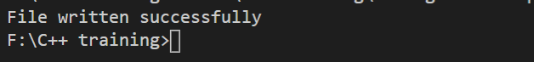

|  |
| --- |
|  |

Program No 4:

Write a program that creates a file **“test.txt”** and write the following lines in that file

If we don‘t work hard,

We will not be able to score high &

might some our class fellow get flunked

repeating the semester again

Write these lines one by one in the same format given above.

|  |
| --- |
| #include <stdio.h>  #include<string.h>  int main()  {     FILE *filepointer;     filepointer = fopen("test.txt","w");     if (filepointer == NULL)     {printf("file failed to open");}     else     {        fputs("If we don‘t work hard,\n",filepointer);        fputs("We will not be able to score high &\n",filepointer);        fputs("might some our class fellow get flunked \n",filepointer);        fputs("repeating the semester again\n",filepointer);     }     fclose(filepointer);      } |

Output:

|  |
| --- |
|  |